Audio Watermarking Via EMD

ABSTRACT

In this paper a new adaptive audio watermarking algorithm based on Empirical Mode Decomposition (EMD) is introduced. The audio signal is divided into frames and each one is decomposed adaptively, by EMD, into intrinsic oscillatory components called Intrinsic Mode Functions(IMFs). The watermark and the synchronization codes are embedded into the extrema of the last IMF, a low frequency mode stable under different attacks and preserving audio perceptual quality of the host signal. The data embedding rate of the proposed algorithm is 46.9– 50.3 b/s. Relying on exhaustive simulations, we show the robustness of the hidden watermark
for additive noise, MP3 compression, re-quantization, filtering, cropping and sampling. The comparison analysis shows that our method has better performance than watermarking schemes reported recently .

INTRODUCTION

Digital audio watermarking has received a great deal of attention in the literature to provide efficient solutions for copyright protection of digital media by embedding a watermark in the original audio signal [1]–[5]. Main requirements of digital audio watermarking are imperceptibility, robustness and data capacity. More precisely, the watermark must be inaudible within the host audio data to maintain audio quality and robust to signal distortions applied to the host data. Finally, the watermark must be easy to extract to prove ownership. To achieve these requirements, seeking new watermarking schemes is a very challenging problem [5]. Different watermarking techniques of varying complexities have been proposed [2]–[5]. In [5] a robust watermarking scheme to different attacks is proposed but with a limited transmission bit rate. To improve the bit rate, watermarked schemes performed in the wavelets domain have been proposed [3], [4]. A limit of wavelet approach is that the basis functions are fixed, and thus they do not necessarily match all real signals. To overcome this limitation, recently, a new signal decomposition method referred to as Empirical Mode Decomposition (EMD) has been introduced for analyzing non-stationary signals derived or not from linear systems in totally adaptive way [6]. A major advantage of EMD relies on no a priori choice of filters or basis functions. Compared to classical kernel based approaches, EMDis fully data-driven method that recursively breaks down any signal into a reduced number of zero-mean with symmetric envelopes AM-FM components called Intrinsic Mode Functions (IMFs).
With the aid of audio watermarking technology it is possible to embed additional information in an audio track. To achieve this, the audio signal of a music recording, an audio book or a commercial is slightly modified in a defined manner. This modification is so slight that the human ear cannot perceive an acoustic difference. Audio watermarking technology thus affords an opportunity to generate copies of a recording which are perceived by listeners as identical to the original but which may differ from one another on the basis of the embedded information.
Only software which embodies an understanding of the type of embedding and embedding parameters is capable of extracting such additional data that were embedded previously. Without such software or if incorrect embedding parameters were selected it is not possible to access these additional data. This prevents unauthorized extraction of embedded information and makes the technique very reliable.
This characteristic is utilized by Music Trace in a targeted manner. Every Music Trace customer receives a unique set of embedding parameters. Consequently, each customer is only capable of extracting that information which he embedded himself. Accessing embedded information of other customers, by contrast, is not possible.
In addition to the inaudibility of the watermark and process security, two other factors play an important role. The first of these is the data rate of the watermark, i.e., an indication of the volume of data which can be transmitted in a given period of time. The other is the robustness of the watermark. Robustness is an indication how reliably a watermark can be extracted after an intentional attack or after transmission and the inherent signal modifications. The watermarking process implemented by Music Trace was investigated by the European Broadcasting Union (EBU) in terms of robustness. Forms of attack investigated included analog conversion of the signal, digital audio coding or repeated filtering of the signal. This revealed that the watermark can no longer be extracted only when the quality of the audio signal has been substantially degraded as a result of the attack The watermark is the copyright information that is embedded into the multimedia content in order to protect it from being illegally copied and distributed. Requirements of the watermark depend on the purpose of its application. A watermark has various features, among which the most important are imperceptibility and robustness, which can conflict with each other. Thus, a compromise is needed [1-3]. In order to satisfy the imperceptibility of the watermark, most of the watermark is embedded into multimedia content as a “noise” both in the time domain and in the frequency domain. Therefore, the energy of the original signal is relatively much stronger than the energy of the watermark. The watermarking detection system proposed by P. Bassia et al. is a blind detection system based on the assumption that the frame size is sufficiently large [4]. In its practical application, however, the frame size is not large enough for the original signal and the watermark to be uncorrelated [5]. Consequently, the detection result based on the system of P. Bassia et al. is affected significantly by the original signal in the practical application. This paper presents a method to reduce the influence of the original signal by employing a simple high-pass filtering using a mean filter. In order to increase robustness, we add the repetitive insertion of the watermark to the embedding system of P. Bassia et al. The work presented here significantly improves the efficiency of watermark detection in the time domain.
The decomposition starts from finer scales to coarser ones. Any signal(t) is expanded by EMD s follows
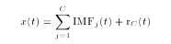
Decomposition of an audio frame by EMD
Data structure Mi
where C is the number of IMFs Rc(t)and denotes the final residual. The IMFs are nearly orthogonal to each other, and all have nearly zero means. The number of extreme is decreased when going from one mode to the next, and the whole decomposition is guaranteed to be completed with a finite number of modes. The IMFs are fully described by their local extreme and thus can be recovered using these extreme [7], [8]. Low frequency components such as higher order IMFs are signal dominated [9] and thus their alteration can lead to degradation of the signal. As result, these modes can be considered to be good locations for watermark placement. Some preliminary results have appeared recently in [10], [11] showing the interest of EMD for audio watermarking. In [10], the EMD is combined with Pulse Code Modulation (PCM) and the watermark is inserted in the final residual of thesubbands in the transform domain. This method supposes that mean value of PCM audio signal may no longer be zero. As stated by the authors, the method is not robust to attacks such as band-pass filtering and cropping, and no comparison to watermarking schemes reported recently in literature is presented. Another strategy is presented in [11] where the EMD is associated with Hilbert transform and the watermark is embedded into the IMF containing highest energy. However, why the IMF carrying the highest amount of energy is the best candidate mode to hide the watermark has not been addressed. Further, in practice an IMF with highest energy can be a high frequency mode and thus it is not robust to attacks. Watermarks inserted into lower order IMFs (high frequency) are most vulnerable to attacks. It has been argued that for watermarking robustness, the watermark bits are usually embedded in the perceptually components, mostly, the low frequency components of the host signal [12]. Compared to [10], [11], to simultaneously have better resistance against attacks and imperceptibility, we embed the watermark in the extreme of the last IMF. Further, unlike the schemes introduced in [10], [11], the proposed watermarking is only based on EMD and without domain transform. We choose in our method a watermarking technique in the category of Quantization Index Modulation (QIM) due to its good robustness and blind nature [13]. Parameters of QIM are chosen to guarantee that the embedded watermark in the last IMF is inaudible. The watermark is associated with a synchronization code to facilitate its location. An advantage to use the time domain approach, based on EMD, is the low cost in searching synchronization codes. Audio signal is first segmented into frames where each one is decomposed adaptively into IMFs. Bits are inserted into the extreme of the last IMF such that the watermarked signal inaudibility is guaranteed. Experimental results demonstrate that the hidden data are robust against
Watermark embedding.
Attacks such as additive noise, MP3 compression, requantization, cropping and filtering. Our method has high data payload and performance againstMP3 compression compared to audio watermarking approaches reported recently in the literature.
Illustrates the proposed watermark embedding process. The audio signal is divided into several fixed-sized frames. In order to alter the DC component of a frame, the frame of a audio signal is processed using following steps;
1) The Discrete Fourier Transform (DFT) is computed for each frame, x[n].The first element of the vector thus computed represents the DC component of the frame.
2) The mean and power content of each frame is calculated as follows,
Frame mean = (1/N) Σ x[n]
Frame power = (1/N) Σ (x[n]) ²
Where N=Number of samples in each frame.
3) The first element of the frame vector obtained Through DFT is modified to represent watermark bit as described above with DC Bias Multiplier = 100.
4) The Inverse Discrete Fourier Transform (IDFT) of the frame vector gives the modified frame.
These steps are performed until all the watermark bits are encoded.

PROPOSED METHOD
PROPOSED WATERMARKING ALGORITHM
The idea of the proposed watermarking method is to hide into the original audio signal a watermark together with a Synchronized Code (SC) in the time domain. The input signal is first segmented into frames and EMD is conducted on every frame to extract the associated IMFs (Fig. 1). Then a binary data sequence consisted of SCs and informative watermark bits (Fig. 2) is embedded in the extreme of a set of consecutive last-IMFs. A bit (0 or 1) is inserted per extreme.
Since the number of IMFs and then their number of extreme depend on the amount of data of each frame, the number of bits to be embedded varies from last-IMF of one frame to the following. Watermark and SCs are not all embedded in extreme of last IMF of only one frame. In general the number of extreme per last-IMF (one frame) is very small compared to length of the binary sequence to be embedded. This also depends on the length of the frame. If we design byN1 andN2the numbers of bits of SC and watermark respectively, the length of binary sequence to be embedded is equal to2N1+2N2, Thus, these2N1+N2 its are spread out on several last-IMFs extreme) of the consecutive frames. Further, this sequence of 2N1+N2 bits bits is embedded times. Finally, inverse transformationEMD^-1is applied to the modified extreme to recover the watermarked audio signal by superposition of the IMFs of each frame followed by the concatenation of the frames Fig. 3). For data extraction, the watermarked audio signal is split into frames and EMD applied to each frame (Fig. 4). Binary data sequences are extracted from each last IMF by searching for SCs (Fig. 5). We show in Fig. 6 the last IMF before and after watermarking. This figure shows that there is little difference in terms of amplitudes between the
two modes. EMD being fully data adaptive, thus it is important to guarantee that the number of IMFs will be same before and after embedding the watermark (Figs. 1, 4). In fact, if the numbers of IMFs are different, there is no guarantee that the last IMF always contains the watermark information to be extracted. To overcome this problem, the sifting of the watermarked signal is forced to extract the same number of IMFs as before watermarking. The proposed watermarking scheme is blind, that is, the host signal is not required for watermark extraction. Overview of the proposed method is detailed as follows

Synchronization Code
To locate the embedding position of the hidden watermark bits in the host signal a SC is used. This code is unaffected by cropping and shifting attacks [4]. Let U be the original SC and be an unknown sequence of the same length. Sequence V is considered as a SC if only the number of
Different bits between and , when compared bit by bit, is less or equal than to a predefined threshold [3].
Decomposition of the watermarked audio frame by EMD.
Watermark Embedding
During production, copyright information in the form of a watermark can be anchored directly in the recording. This makes it possible to check at a later time whether a competitor, for example, has taken samples of music played on a valuable instrument and used them in his product without permission. With the aid of the watermark, it is also possible to provide copyright verification in the event that a competitor claims he produced a given title It can also be expedient to utilize audio watermarking of promotional recordings provided to radio stations or the press or when music tracks or audio books are sold by an Internet shop. Here the idea is to personalize every recording distributed. In such cases information is embedded as a watermark that can be used at a later time to monitor recipients. This can be the recipient's customer number, for example. If these recordings are found later on the Internet, the embedded data can be used to identify the person to whom the recorded material was originally distributed.
The advantage of the watermarking technique over the Digital Rights Management (DRM) technique is that the original multimedia format is not changed by the watermark. To illustrate this, if a watermark is embedded in an MP3 file, the result is an MP3 file that can be played on any commercially-available MP3 player. It is therefore not necessary for customers to purchase special playback devices. Furthermore, the watermark remains in the recording even in the event of format conversion, even if the material undergoes analog conversion.

Before embedding, SCs are combined with watermark bits to form a binary sequence denoted by math bit of watermark (Fig. 2). Basics of our watermark embedding are shown in Fig. 3 and detailed as follows:
Step 1: Split original audio signal into frames.
Step 2: Decompose each frame into IMFs.
Step 3: Embed p times the binary sequence {m,}into extreme of the last IMF(IMFc) by QIM [13]:
where and are the extreme of of the host audio signal and the watermarked signal respectively. sign function is equal to “ ” if is a maxima, and “ ” if it is a minimal. denotes the floor function, and S denotes the embedding strength chosen to maintain the inaudibility constraint.
Step 4: Reconstruct the frame using modified and concatenate the watermarked frames to retrieve the watermarked signal.
C. Watermark Extraction
There are two ways that a pirate can defeat a watermarking scheme. The first is to manipulate the audio signal to make all watermarks undetectable by any recovery mechanism. The second is to create a situation where the watermarking detection algorithm generates a false result that is equal to the probability of a true result (Boney, et al., 1996).
The detection of the watermarking signal is the most important aspect of the entire watermarking process. For if one cannot easily and reliably extract the actual data that was inserted in the original signal, it matters little what exotic techniques were used to perform this insertion. The watermark extraction will occur in the presence of jamming signals and the above real life harsh audio conditions.
An audio watermark is a kind of digital watermark —a marker embedded in an audio signal, typically to identify ownership of copyright for that audio. Watermarking is the process of embedding information into a signal (e.g. audio, video or pictures) in a way that is difficult to remove. If the signal is copied, then the information is also carried in the copy. A signal may carry several different watermarks at the same time. Watermarking has become increasingly important to enable copyright protection and ownership verification.
One of the most secure techniques of audio watermarking is spread spectrum audio watermarking (SSW). Spread Spectrum is a general technique for embedding watermarks that can be implemented in any transform domain or in the time domain. In SSW, a narrow-band signal is transmitted over a much larger bandwidth such that the signal energy presented in any signal frequency is undetectable. Thus the watermark is spread over many frequency bins so that the energy in one bin is undetectable. An interesting feature of this watermarking technique is that destroying it requires noise of high amplitude to be added to all frequency bins. This type of watermarking is robust since to be confident of eliminating a watermark, the attack must attack all possible frequency bins with modifications of considerable strength. This will create visible defects in the data.
Spreading spectrum is done by a pseudo noise (PN) sequence. In conventional SSW approaches, the receiver must know the PN sequence used at the transmitter as well as the location of the watermark in the watermarked signal for detecting hidden information. This is a high security feature, since any unauthorized user who does not have access to this information cannot detect any hidden information. Detection of the PN sequence is the key factor for detection of hidden information from SSW.
Although PN sequence detection is possible by using heuristic approaches such as evolutionary algorithms, the high computational cost of this task can make it impractical. Much of the computational complexity involved in the use of evolutionary algorithms as an optimization tool is due to the fitness function evaluation that may either be very difficult to define or be computationally very expensive. One of the recent proposed approaches -in fast recovering the PN sequence- is the use of fitness granulation as a promising fitness approximation scheme. With the use of the fitness granulation approach called Adaptive Fuzzy Fitness Granulation (AFFG), the expensive fitness evaluation step is replaced by an approximate model. When evolutionary algorithms are used as a means to extract the hidden information, the process is called Evolutionary Hidden Information Detection, whether fitness approximation approaches are used as a tool to accelerate the process or not

For watermark extraction, host signal is splitted into frames and EMDis performed on each one as in embedding. We extract binary data using rule given by (3). We then search for SCs in the extracted data. This procedure is repeated by shifting the selected segment (window) one sample at time until a SC is found. With the position of SC determined, we can then extract the hidden information bits, which follow the SC. Let denote the binary data to be extracted and denote the original SC. To locate the embedded watermark we search the SCs in the sequence bit by bit. The extraction is performed without using the original audio signal. Basic steps involved in the watermarking extraction, shown in Fig. 5, are given as follows:
Step 1: Split the watermarked signal into frames.
Step 2: Decompose each frame into IMFs.
Step 3: Extract the extreme of .
Watermark extraction
Last IMF of an audio frame before and after watermarking
Step 4: Extract from using the following rule
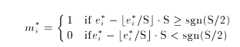
Step 5 :Set the start index of the extracted data, y of T=1to and select L=N1samples (sliding window size).
Step 6;Evaluate the similarity between the extracted segment V=y(I:L) and bit by bit. If the similarity value >_tis , then is taken as the SC and go to Step 8. Otherwise proceed to the next step.

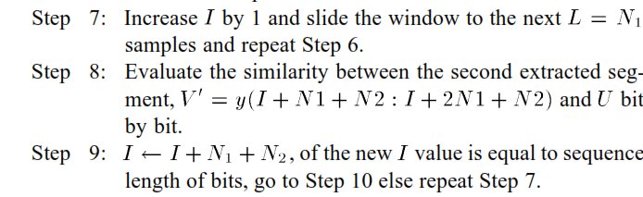
Step 10: Extract the watermarks’ and make comparison bit by bit between these marks, for correction, and finally extract the desired watermark Watermarking embedding and extraction processes are summarized in Fig. 7.
PERFORMANCE ANALYSIS
We evaluate the performance of our method in terms of data payload, error probability of SC, Signal to Noise Ratio (SNR) between original and the watermarked audio signals, Bit Error Rate and Normalized cross-Correlation . According to International Federation of the Photographic Industry (IFPI) recommendations, a watermark audio signal should maintain more than 20 dB SNR. To evaluate the watermark detection accuracy after attacks, we used the and the defined
as follows [4]:
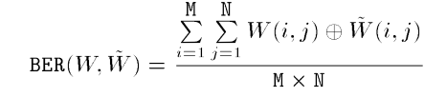
where is the XOR operator and M*Nare the binary watermark image sizes. and are the riginal and the recovered watermark respectively. is used to evaluate the watermark detection accuracy after signal processing operations. To evaluate the similarity between
Embedding and extraction processes

Binary watermark
the original watermark and the extracted one we use the measure defined as follows
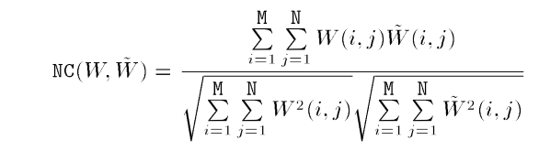
A large NC indicates the presence of watermark while a low value suggests the lack of watermark. Two types of errors may occur while searching the SCs: the False Positive Error (FPE) and the False Negative Error (FNE). These errors are very harmful because they impair the credibility of the watermarking system. The associated probabilities of these errors are given by
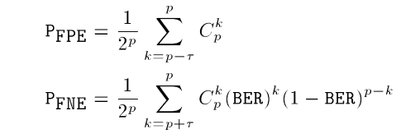
where is the SC length and is is the threshold. is the probability that a SC is detected in false location while is the probability that a watermarked signal is declared as unwatermarked by the decoder. We also use as performance measure the payload which quantifies the amount of information to be hidden. More precisely, the data payload refers to the number of bits that are embedded into that audio signal within a unit of time and is measured in unit of bits per second
(b/s)
A portion of the pop audio signal and its watermarked version

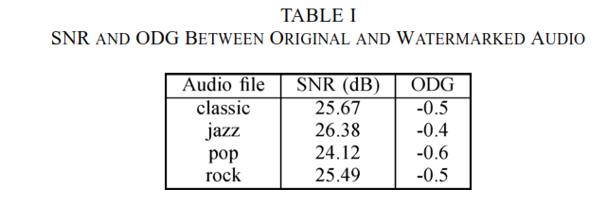
Empirical Mode Decomposition
During the last decade, wavelet-based techniques (and variations) have proved remarkably effective for representing and analyzing various stochastic processes, and especially those with scaling properties [1]. Amongst a number of reasons for this success stands first the adequacy between the multiscale nature of such processes and the built-in multiscale structure of wavelet decompositions, as well as companion benefits in terms of stationarization and reduced correlation. More recently, an apparently unrelated technique, referred to as Empirical Mode Decomposition (EMD), has been pioneered by Huang et al. [2] for adaptively representing functions as sums of zero-mean components with symmetric envelopes. Such a decomposition is based on an idea of locally extracting fine scale fluctuations in a signal and iterating the procedure on the (locally lower scale) residual. As such, EMD corresponds in some sense to a hierarchical multiscale decomposition but, in contrast with wavelet techniques, it is fully data-driven and relies on no a priori choice of filters or basis functions. Nevertheless, it has
been shown that, when applied to broadband processes such as fractional Gaussian noise or fractional Brownian motion, EMD behaves spontaneously as a dyadic filter bank resembling those involved in wavelet decompositions [3]. We will here report on our findings in this direction and compare EMD with wavelet-based techniques in terms of decor relation properties,
Hurst exponent estimation and trend removal capabilities. The EMD approach is intuitive and appealing, but the decomposition is only obtained as the output of an algorithm for which no well-founded theory is available yet. The presented results will therefore be based on extensive numerical simulations performed with freeware Matlab codes However, many physical situations are known to undergo no stationary and/or nonlinear behaviors we can think of representing these signals in terms of amplitude and frequency modulated (AM–FM) components 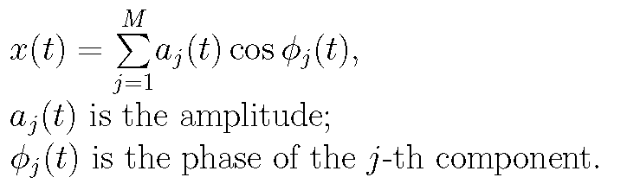
The rationale for such a modeling is to compactly encode possible nonstationarities in a time variation of the amplitudes and frequencies of Fourier-like modes More generally, signals may also be generated by nonlinear systems for which oscillations are not necessarily associated with circular functions, thus suggesting decompositions of the following form
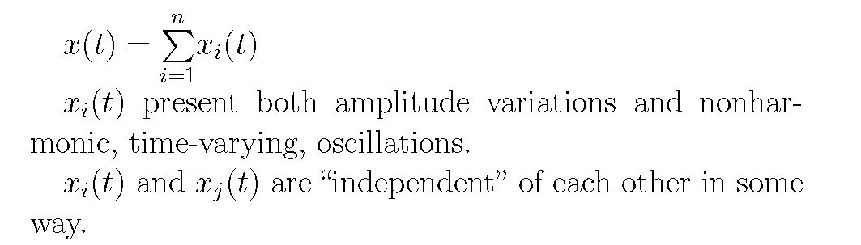
Empirical Mode Decomposition (EMD) is designed primarily for obtaining representations of Type II or TypeIII in the case of signals which are oscillatory, possibly nonstationary or generated by a nonlinear system, in some automatic, fully data-driven way The starting point of EMD is to consider oscillatory signals at the level of their local oscillations and to formalize the idea that: signal = fast oscillations superimposed to slow oscillations
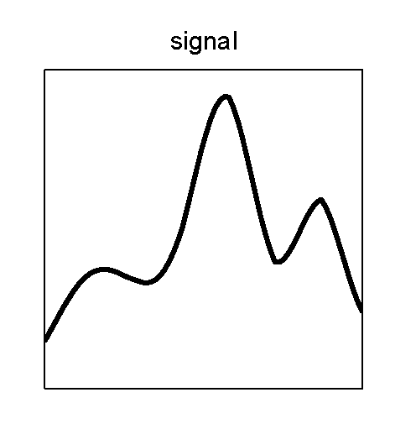
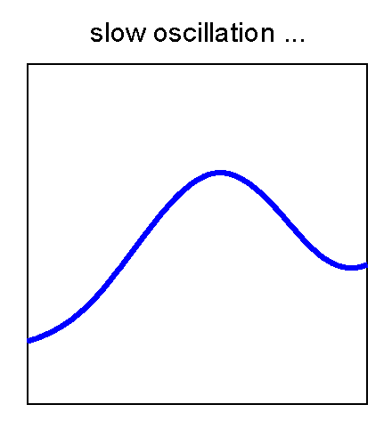
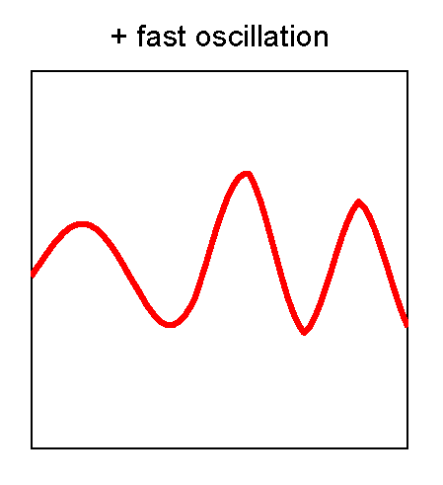
signal = fast oscillations superimposed to slow oscillations
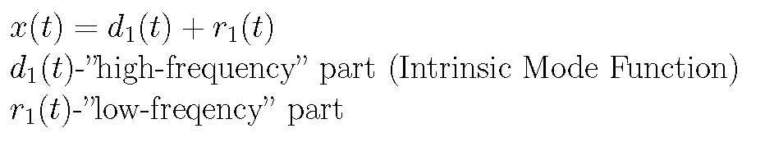
Iterate on the slow oscillations component considered as a new signa
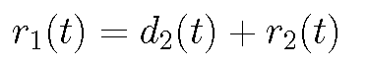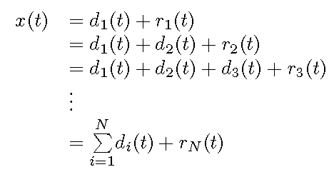
Empirical Mode Decomposition (EMD) Decomposing a complicated set of data into a finite number of Intrinsic Mode Functions (IMF), that admit well behaved Hilbert Transforms Intrinsic Mode Functions (IMF)
- In the whole set of data, the numbers of local extrema and the numbers of zero crossings must be equal or differ by 1 at most
- 2. At any time point, the mean value of the “upper envelope” (defined by the local Maxima) and the “lower envelope” (defined by the local minima) must be zero.
Intrinsic Mode Function
Both time analysis and frequency analysis are the basic signal processing methods. Some fundamental physical quantities such as the field, pressure, and voltage, themselves change in time, so they are called ”time waveforms” or ”signals”.The time analysis, which investigates the variation of a signal with respect to time, is fundamental because a signal itself is a time waveform. However, to probe deeper, the study of different representations of a signal is often useful. This study is implemented by expanding a signal into a complete set of functions. From a mathematical point of view, there are infinite ways to expand a signal. What makes a particular
representation important is that the characteristics of the signal are understood better in that representation. Besides time, the second most important representation is frequency. The signal analysis based on frequency is called ”frequency analysis”. As a classic example of frequency analysis, the Fourier analysis has played an important role in stationary signal analysis and has been successful in many applications since it was proposed in 1807 [1]. Although the Fourier analysis is valid under extremely general conditions, there are some crucial restrictions of the Fourier spectral analysis: the system must be linear and the data must be strictly periodic or stationary, otherwise the resulting spectrum will make little physical sense. These restrictions suggest that some more strict conditions will be necessary to analyze a non-stationary signal.Over the years, scientists have tried to find some available, adaptive and effective methods to process and analyze nonlinear and non-stationary data. Some methods have been foundsuch as the spectrogram, the short-time Fourier transform, the Wigner-Ville distribution, the evolutionary spectrum, the wavelet transform, the empirical orthogonal function expansion and other miscellaneous methods [1], [2]. However, almost all of them depend on the Fourier analysis. A key point of these methods is that all of them try to modify the global representation of the Fourier analysis into a local one, which means that some intrinsic difficulties are nevitable. Hence,only a few of them perform really well unless in some special applications. Until now, wavelet analysis is still one of the best technologies for non-stationary signal analysis. It is often powerful, especially when the frequencies of a signal vary progressively. However, it can just be regarded as an extension of the Fourier analysis, because it also needs to expand a signal under a specified basis [2]. Once the selected basis does not match with the signal itself very well, the results are often unreliable.

The key point of developing adaptive and effective methods is the intrinsic and adaptive representations for the oscillatory modes of nonlinear and non-stationary signals. After considerable explorations, researchers have gradually realized that a complex signal should consist of some simple signals, each of which involves only one oscillatory mode at any time instance. These simple signals are called ”mono-component signal” [1]. On the other hand, a superposition of some mono-component signals can form a complex signal. A real signal is often
a complex one. Based on this model, Boashash has given a detailed discussion about the instantaneous frequencies of a signal and their corresponding time-frequency distributions [3]. However, up until now, it is still hard to accurately explain the significance of having only one oscillatory mode in any time location. Thus, there is no clear and accepted definition of how to judge whether or not a signal is a mono-component one. Some researchers have suggested that the time-frequency distribution of a given signal should be defined first. Once the time-frequency distribution has been obtained, it will be easy to determine whether or not a signal is a mono-component one [4]. However, there are still almost insurmountable difficulties to find a logical time-frequency distribution. A new mono-component signal model, which is called ”Intrinsic Mode Function (IMF)”, was proposed by Huang et. al in 1998 [5]. Meanwhile, a new algorithm entitled ”Empirical Mode Decomposition (EMD)” [5] was developed to adaptively decompose a signal into a number of IMFs. With the Hilbert transform, the IMFs yield instantaneous frequencies as functions of time that give sharp identifications of imbedded structures. The final presentation is an energyfrequency- time distribution, designated as the Hilbert spectrum. Being different from the Fourier decomposition and the wavelet decomposition, EMD has no specified ”basis”. Its ”basis” is adaptively produced depending on the signal itself, which makes not only decomposition efficiency very high but also makes localization of the Hilbert spectrum both on frequency and time much sharper and most important of all, makes much physical sense. Because of its excellence, EMD has been utilized and studied widely by researchers and experts in signal processing and other related fields [6], [7], [8], [9], [10]. Its applications have spread rom earthquake research [11], to ocean science [12], fault diagnosis [13], signal denoising [14], image processing [15], [16], biomedical signal processing [17], speech signal analysis [18], pattern recognition [19] and so on. Both conditions of the IMF have tried to restrict an IMF by involving only one oscillatory mode in any time location and by making the oscillations symmetric with respect to the time axis. The similar function of the two conditions has driven us
to consider their relativity. After an acute analysis, we have proven that Condition 1 of the IMF can really be deduced from Condition 2. Finally, an improved definition of the IMF is given. The rest of the paper is organized as follows: Section 2 contains the analysis of the definition of the intrinsic mode function. Section 3 plays a core role, in which some key results are proven and an improved definition of the intrinsic mode function is given.
ANALYSIS OF THE IMF
The original objective of EMD was to identify the intrinsic oscillatory modes in each time location from a signal, one by one. With EMD, any complicated signal can be decomposed into a finite number of simple signals, each of which includes only one oscillatory mode in any time location. These extracted simple signals actually serve as approximations of so-called mono-component signals. However, it is difficult to tell what is an intrinsic oscillatory mode of a signal in a time location. This problem looks simple, but is really difficult. Intuitively, there are two ways to identify an intrinsic oscillatory mode: by the time lapse between the successive alternations of local maxima and minima such as A → B → C as shown in figure 1; and by the time lapse between the successive zero crossings such as D → E → F as shown in the same figure [23].

RESULTS

To show the effectiveness of our scheme, simulations are performed on audio signals including pop, jazz, rock and classic sampled at 44.1 kHz. The embedded watermark,W, is a binary logo image of size bits (Fig. 8). We convert this 2D binary M*N=43*48=1632 image into 1D sequence in order to embed it into the audio signal. The C used is a 16 bit Barker sequence 1111100110101110. Each audio signal is divided into frames of size 64 samples and the threshold is set to 4. The value is fixed to 0.98. These parameters have been chosen to have a good compromise between imperceptibility of the watermarked signal, payload and robustness. Fig. 9 shows a portion of the pop signal and its watermarked version. This figure shows that the watermarked signal is visually indistinguishable from the original one.

Perceptual quality assessment can be performed using subjective listening tests by human acoustic perception or using objective evaluation tests by measuring the SNR and Objective Difference Grade (ODG). In this work we use the second approach. ODG and SNR values of the
four watermarked signals are reported in Table I. The SNR values are above 20 dB showing the good choice of value and confirming to IFPI standard. All ODG values of the watermarked audio signals are between and 0 which demonstrates their good quality.s
A. Robustness Test
To asses the robustness of our approach, different attacks are performed:
—Noise:White Gaussian Noise (WGN) is added to the watermarked signal until the resulting signal has an SNR of 20 dB.
—Filtering: Filter the watermarked audio signal usingWiener filter.
—Cropping: Segments of 512 samples are removed from the watermarked signal at thirteen positions and subsequently replaced by segments of the watermarked signal contaminated withWGN
Pfpe versus synchronization code length.
Pfne versus the length of embedding bits

—Resampling: The watermarked signal, originally sampled at 44.1 kHz, is re-sampled at 22.05 Hz and restored back bysampling again at 44.1 kHz.
—Compression: (64 kb/s and 32 kb/s)UsingMP3, the watermarked signal is compressed and then decompressed.
—Requantization: The watermarked signal is re-quantized down to 8 bits/sample and then back to 16 bits/sample. Table II shows the extracted watermarks with the associated and values for different attacks on pop audio signal. values are all above 0.9482 and most values are all below 3%. The extracted watermark are visually similar to the original watermark. These results
shows the robustness of watermarking method for pop audio signal. Even in the case ofWGN attack with SNR of 20 dB, our approach does not detects any error. This is mainly due to the insertion of the watermark into extrema. In fact low frequency subband has high robustness against noise addition [3], [4]. Table III reports similar results for classic, jazz and rock audio files. values are all above 0.9964 and values are all below 3%, demonstrating the good performance robustness of our method on these audio files. This is robustness is dueto the fact hat even the perceptual characteristics of individual audio files vary, the EMD decomposition adapts to each one. Table IV shows comparison results in terms of payload and robustness to P3 compressionattack of our method to nine recent watermarking schemes .
TABLE II
BER AND NC OF EXTRACTED WATERMARK FOR POP AUDIO SIGNAL BY PROPOSED APPROACH

TABLE III
BER AND NC OF EXTRACTED WATERMARK FOR DIFFERENT AUDIO SIGNALS (CLASSIC, JAZZ, ROCK) BY OUR APPROACH
TABLE IV
COMPARISON OF AUDIO WATERMARKING METHODS, SORTED BY ATTEMPTED PAYLOAD

MATLAB

INTRODUCTION TO MATLAB
What Is MATLAB?
MATLAB® is a high-performance language for technical computing. It integrates computation, visualization, and programming in an easy-to-use environment where problems and solutions are expressed in familiar mathematical notation. Typical uses include
Math and computation
Algorithm development
Data acquisition
Modeling, simulation, and prototyping
Data analysis, exploration, and visualization
Scientific and engineering graphics
Application development, including graphical user interface building.
MATLAB is an interactive system whose basic data element is an array that does not require dimensioning. This allows you to solve many technical computing problems, especially those with matrix and vector formulations, in a fraction of the time it would take to write a program in a scalar non interactive language such as C or FORTRAN.
The name MATLAB stands for matrix laboratory. MATLAB was originally written to provide easy access to matrix software developed by the LINPACK and EISPACK projects. Today, MATLAB engines incorporate the LAPACK and BLAS libraries, embedding the state of the art in software for matrix computation.
MATLAB has evolved over a period of years with input from many users. In university environments, it is the standard instructional tool for introductory and advanced courses in mathematics, engineering, and science. In industry, MATLAB is the tool of choice for high-productivity research, development, and analysis.
MATLAB features a family of add-on application-specific solutions called toolboxes. Very important to most users of MATLAB, toolboxes allow you to learn and apply specialized technology. Toolboxes are comprehensive collections of MATLAB functions (M-files) that extend the MATLAB environment to solve particular classes of problems. Areas in which toolboxes are available include signal processing, control systems, neural networks, fuzzy logic, wavelets, simulation, and many others.
The MATLAB System:
The MATLAB system consists of five main parts:
Development Environment:
This is the set of tools and facilities that help you use MATLAB functions and files. Many of these tools are graphical user interfaces. It includes the MATLAB desktop and Command Window, a command history, an editor and debugger, and browsers for viewing help, the workspace, files, and the search path.
The MATLAB Mathematical Function:
This is a vast collection of computational algorithms ranging from elementary functions like sum, sine, cosine, and complex arithmetic, to more sophisticated functions like matrix inverse, matrix eigen values, Bessel functions, and fast Fourier transforms.
The MATLAB Language:
This is a high-level matrix/array language with control flow statements, functions, data structures, input/output, and object-oriented programming features. It allows both "programming in the small" to rapidly create quick and dirty throw-away programs, and "programming in the large" to create complete large and complex application programs.
Graphics:
MATLAB has extensive facilities for displaying vectors and matrices as graphs, as well as annotating and printing these graphs. It includes high-level functions for two-dimensional and three-dimensional data visualization, image processing, animation, and presentation graphics. It also includes low-level functions that allow you to fully customize the appearance of graphics as well as to build complete graphical user interfaces on your MATLAB applications.

The MATLAB Application Program Interface (API):
This is a library that allows you to write C and Fortran programs that interact with MATLAB. It includes facilities for calling routines from MATLAB (dynamic linking), calling MATLAB as a computational engine, and for reading and writing MAT-files.
MATLAB WORKING ENVIRONMENT:

MATLAB DESKTOP:-
Matlab Desktop is the main Matlab application window. The desktop contains five sub windows, the command window, the workspace browser, the current directory window, the command history window, and one or more figure windows, which are shown only when the user displays a graphic.
The command window is where the user types MATLAB commands and expressions at the prompt (>>) and where the output of those commands is displayed. MATLAB defines the workspace as the set of variables that the user creates in a work session. The workspace browser shows these variables and some information about them. Double clicking on a variable in the workspace browser launches the Array Editor, which can be used to obtain information and income instances edit certain properties of the variable.
The current Directory tab above the workspace tab shows the contents of the current directory, whose path is shown in the current directory window. For example, in the windows operating system the path might be as follows: C:\MATLAB\Work, indicating that directory “work” is a subdirectory of the main directory “MATLAB”; WHICH IS INSTALLED IN DRIVE C. clicking on the arrow in the current directory window shows a list of recently used paths. Clicking on the button to the right of the window allows the user to change the current directory.
MATLAB uses a search path to find M-files and other MATLAB related files, which are organize in directories in the computer file system. Any file run in MATLAB must reside in the current directory or in a directory that is on search path. By default, the files supplied with MATLAB and math works toolboxes are included in the search path. The easiest way to see which directories are on the search path. The easiest way to see which directories are soon the search path, or to add or modify a search path, is to select set path from the File menu the desktop, and then use the set path dialog box. It is good practice to add any commonly used directories to the search path to avoid repeatedly having the change the current directory.

The Command History Window contains a record of the commands a user has entered in the command window, including both current and previous MATLAB sessions. Previously entered MATLAB commands can be selected and re-executed from the command history window by right clicking on a command or sequence of commands. This action launches a menu from which to select various options in addition to executing the commands. This is useful to select various options in addition to executing the commands. This is a useful feature when experimenting with various commands in a work session.
Using the MATLAB Editor to create M-Files:
The MATLAB editor is both a text editor specialized for creating M-files and a graphical MATLAB debugger. The editor can appear in a window by itself, or it can be a sub window in the desktop. M-files are denoted by the extension .m, as in pixelup.m. The MATLAB editor window has numerous pull-down menus for tasks such as saving, viewing, and debugging files. Because it performs some simple checks and also uses color to differentiate between various elements of code, this text editor is recommended as the tool of choice for writing and editing M-functions. To open the editor , type edit at the prompt opens the M-file filename.m in an editor window, ready for editing. As noted earlier, the file must be in the current directory, or in a directory in the search path.
Getting Help:
The principal way to get help online is to use the MATLAB help browser, opened as a separate window either by clicking on the question mark symbol (?) on the desktop toolbar, or by typing help browser at the prompt in the command window. The help Browser is a web browser integrated into the MATLAB desktop that displays a Hypertext Markup Language(HTML) documents. The Help Browser consists of two panes, the help navigator pane, used to find information, and the display pane, used to view the information. Self-explanatory tabs other than navigator pane are used to perform a search.

DIGITAL IMAGE PROCESSING

Digital image processing
Background:
Digital image processing is an area characterized by the need for extensive experimental work to establish the viability of proposed solutions to a given problem. An important characteristic underlying the design of image processing systems is the significant level of testing & experimentation that normally is required before arriving at an acceptable solution. This characteristic implies that the ability to formulate approaches &quickly prototype candidate solutions generally plays a major role in reducing the cost & time required to arrive at a viable system implementation.

What is DIP
An image may be defined as a two-dimensional function f(x, y), where x & y are spatial coordinates, & the amplitude of f at any pair of coordinates (x, y) is called the intensity or gray level of the image at that point. When x, y & the amplitude values of f are all finite discrete quantities, we call the image a digital image. The field of DIP refers to processing digital image by means of digital computer. Digital image is composed of a finite number of elements, each of which has a particular location & value. The elements are called pixels.
Vision is the most advanced of our sensor, so it is not surprising that image play the single most important role in human perception. However, unlike humans, who are limited to the visual band of the EM spectrum imaging machines cover almost the entire EM spectrum, ranging from gamma to radio waves. They can operate also on images generated by sources that humans are not accustomed to associating with image.
There is no general agreement among authors regarding where image processing stops & other related areas such as image analysis& computer vision start. Sometimes a distinction is made by defining image processing as a discipline in which both the input & output at a process are images. This is limiting & somewhat artificial boundary. The area of image analysis (image understanding) is in between image processing & computer vision.
There are no clear-cut boundaries in the continuum from image processing at one end to complete vision at the other. However, one useful paradigm is to consider three types of computerized processes in this continuum: low-, mid-, & high-level processes. Low-level process involves primitive operations such as image processing to reduce noise, contrast enhancement & image sharpening. A low- level process is characterized by the fact that both its inputs & outputs are images.

Mid-level process on images involves tasks such as segmentation, description of that object to reduce them to a form suitable for computer processing & classification of individual objects. A mid-level process is characterized by the fact that its inputs generally are images but its outputs are attributes extracted from those images. Finally higher- level processing involves “Making sense” of an ensemble of recognized objects, as in image analysis & at the far end of the continuum performing the cognitive functions normally associated with human vision.
Digital image processing, as already defined is used successfully in a broad range of areas of exceptional social & economic value.
What is an image?
An image is represented as a two dimensional function f(x, y) where x and y are spatial co-ordinates and the amplitude of ‘f’ at any pair of coordinates (x, y) is called the intensity of the image at that point.
Gray scale image:
A grayscale image is a function I (xylem) of the two spatial coordinates of the image plane.
I(x, y) is the intensity of the image at the point (x, y) on the image plane.
I (xylem) takes non-negative values assume the image is bounded by a rectangle [0, a] ×[0, b]I: [0, a] × [0, b] → [0, info)
Color image:
It can be represented by three functions, R (xylem) for red, G (xylem) for green and B (xylem) for blue.
An image may be continuous with respect to the x and y coordinates and also in amplitude. Converting such an image to digital form requires that the coordinates as well as the amplitude to be digitized. Digitizing the coordinate’s values is called sampling. Digitizing the amplitude values is called quantization.
Coordinate convention:
The result of sampling and quantization is a matrix of real numbers. We use two principal ways to represent digital images. Assume that an image f(x, y) is sampled so that the resulting image has M rows and N columns. We say that the image is of size M X N. The values of the coordinates (xylem) are discrete quantities. For notational clarity and convenience, we use integer values for these discrete coordinates.
In many image processing books, the image origin is defined to be at (xylem)=(0,0).The next coordinate values along the first row of the image are (xylem)=(0,1).It is important to keep in mind that the notation (0,1) is used to signify the second sample along the first row. It does not mean that these are the actual values of physical coordinates when the image was sampled. Following figure shows the coordinate convention. Note that x ranges from 0 to M-1 and y from 0 to N-1 in integer increments.
The coordinate convention used in the toolbox to denote arrays is different from the preceding paragraph in two minor ways. First, instead of using (xylem) the toolbox uses the notation (race) to indicate rows and columns. Note, however, that the order of coordinates is the same as the order discussed in the previous paragraph, in the sense that the first element of a coordinate topples, (alb), refers to a row and the second to a column. The other difference is that the origin of the coordinate system is at (r, c) = (1, 1); thus, r ranges from 1 to M and c from 1 to N in integer increments. IPT documentation refers to the coordinates. Less frequently the toolbox also employs another coordinate convention called spatial coordinates which uses x to refer to columns and y to refers to rows. This is the opposite of our use of variables x and y.
Image as Matrices:
The preceding discussion leads to the following representation for a digitized image function:
f (0,0) f(0,1) ……….. f(0,N-1)
f (1,0) f(1,1) ………… f(1,N-1)
f (xylem)= . . .
. . .
f (M-1,0) f(M-1,1) ………… f(M-1,N-1)
The right side of this equation is a digital image by definition. Each element of this array is called an image element, picture element, pixel or pel. The terms image and pixel are used throughout the rest of our discussions to denote a digital image and its elements.

A digital image can be represented naturally as a MATLAB matrix:
f (1,1) f(1,2) ……. f(1,N)
f (2,1) f(2,2) …….. f (2,N)
. . .
f = . . .
f (M,1) f(M,2) …….f(M,N)
Where f (1,1) = f(0,0) (note the use of a monoscope font to denote MATLAB quantities). Clearly the two representations are identical, except for the shift in origin. The notation f(p ,q) denotes the element located in row p and the column q. For example f(6,2) is the element in the sixth row and second column of the matrix f. Typically we use the letters M and N respectively to denote the number of rows and columns in a matrix. A 1xN matrix is called a row vector whereas an Mx1 matrix is called a column vector. A 1x1 matrix is a scalar.
Matrices in MATLAB are stored in variables with names such as A, a, RGB, real array and so on. Variables must begin with a letter and contain only letters, numerals and underscores. As noted in the previous paragraph, all MATLAB quantities are written using mono-scope characters. We use conventional Roman, italic notation such as f(x ,y), for mathematical expressions

Reading Images:
Images are read into the MATLAB environment using function imread whose syntax is
Imread (‘filename’)
Format name Description recognized extension
TIFF Tagged Image File Format .tif, .tiff
JPEG Joint Photograph Experts Group .jpg, .jpeg
GIF Graphics Interchange Format .gif
BMP Windows Bitmap .bmp

PNG Portable Network Graphics .png
XWD X Window Dump .xwd
Here filename is a spring containing the complete of the image file(including any applicable extension).For example the command line
>> f = imread (‘8. jpg’);
Reads the JPEG (above table) image chestxray into image array f. Note the use of single quotes (‘) to delimit the string filename. The semicolon at the end of a command line is used by MATLAB for suppressing output If a semicolon is not included. MATLAB displays the results of the operation(s) specified in that line. The prompt symbol (>>) designates the beginning of a command line, as it appears in the MATLAB command window.
Data Classes:
Although we work with integers coordinates the values of pixels themselves are not restricted to be integers in MATLAB. Table above list various data classes supported by MATLAB and IPT are representing pixels values. The first eight entries in the table are refers to as numeric data classes. The ninth entry is the char class and, as shown, the last entry is referred to as logical data class.
All numeric computations in MATLAB are done in double quantities, so this is also a frequent data class encounter in image processing applications. Class unit 8 also is encountered frequently, especially when reading data from storages devices, as 8 bit images are most common representations found in practice. These two data classes, classes logical, and, to a lesser degree, class unit 16 constitute the primary data classes on which we focus. Many ipt functions however support all the data classes listed in table. Data class double requires 8 bytes to represent a number uint8 and int 8 require one byte each, uint16 and int16 requires 2bytes and unit 32.
Name Description
Double Double _ precision, floating_ point numbers the Approximate.
Uint8 unsigned 8_bit integers in the range [0,255] (1byte per Element).
Uint16 unsigned 16_bit integers in the range [0, 65535] (2byte per element).
Uint 32 unsigned 32_bit integers in the range [0, 4294967295](4 bytes per element). Int8 signed 8_bit integers in the range [-128,127] 1 byte per element)
Int 16 signed 16_byte integers in the range [32768, 32767] (2 bytes per element).
Int 32 Signed 32_byte integers in the range [-2147483648, 21474833647] (4 byte per element).
Single single _precision floating _point numbers with values
In the approximate range (4 bytes per elements)
Char characters (2 bytes per elements).
Logical values are 0 to 1 (1byte per element).
Int 32 and single required 4 bytes each. The char data class holds characters in Unicode representation. A character string is merely a 1*n array of characters logical array contains only the values 0 to 1,with each element being stored in memory using function logical or by using relational operators.
Image Types:
The toolbox supports four types of images:
1 .Intensity images;
2. Binary images;
3. Indexed images;
4. R G B images.
Most monochrome image processing operations are carried out using binary or intensity images, so our initial focus is on these two image types. Indexed and RGB colour images.
Intensity Images:
An intensity image is a data matrix whose values have been scaled to represent intentions. When the elements of an intensity image are of class unit8, or class unit 16, they have integer values in the range [0,255] and [0, 65535], respectively. If the image is of class double, the values are floating point numbers. Values of scaled, double intensity images are in the range [0, 1] by convention.

Binary Images:
Binary images have a very specific meaning in MATLAB.A binary image is a logical array 0s and1s.Thus, an array of 0s and 1s whose values are of data class, say unit8, is not considered as a binary image in MATLAB .A numeric array is converted to binary using function logical. Thus, if A is a numeric array consisting of 0s and 1s, we create an array B using the statement.
B=logical (A)
If A contains elements other than 0s and 1s.Use of the logical function converts all nonzero quantities to logical 1s and all entries with value 0 to logical 0s.
Using relational and logical operators also creates logical arrays.
To test if an array is logical we use the I logical function: islogical(c).
If c is a logical array, this function returns a 1.Otherwise returns a 0. Logical array can be converted to numeric arrays using the data class conversion functions.

Indexed Images:
An indexed image has two components:
A data matrix integer, x
A color map matrix, map
Matrix map is an m*3 arrays of class double containing floating point values in the range [0, 1].The length m of the map are equal to the number of colors it defines. Each row of map specifies the red, green and blue components of a single color. An indexed images uses “direct mapping” of pixel intensity values color map values. The color of each pixel is determined by using the corresponding value the integer matrix x as a pointer in to map. If x is of class double ,then all of its components with values less than or equal to 1 point to the first row in map, all components with value 2 point to the second row and so on. If x is of class units or unit 16, then all components value 0 point to the first row in map, all components with value 1 point to the second and so on.
RGB Image:

An RGB color image is an M*N*3 array of color pixels where each color pixel is triplet corresponding to the red, green and blue components of an RGB image, at a specific spatial location. An RGB image may be viewed as “stack” of three gray scale images that when fed in to the red, green and blue inputs of a color monitor
Produce a color image on the screen. Convention the three images forming an RGB color image are referred to as the red, green and blue components images. The data class of the components images determines their range of values. If an RGB image is of class double the range of values is [0, 1].
Similarly the range of values is [0,255] or [0, 65535].For RGB images of class units or unit 16 respectively. The number of bits use to represents the pixel values of the component images determines the bit depth of an RGB image. For example, if each component image is an 8bit image, the corresponding RGB image is said to be 24 bits deep.
Generally, the number of bits in all component images is the same. In this case the number of possible color in an RGB image is (2^b) ^3, where b is a number of bits in each component image. For the 8bit case the number is 16,777,216 colors.

CONCLUSION

In this paper a new adaptive watermarking scheme based on the EMD is proposed. Watermark is embedded in very low frequency mode (last IMF), thus achieving good performance against various attacks. Watermark is associated with synchronization codes and thus the synchronized
Watermark has the ability to resist shifting and cropping. Data bits of the synchronized watermark are embedded in the extreme the last IMF of the audio signal based on QIM. Extensive simulations over different audio signals indicate that the proposed watermarking scheme has greater robustness against common attacks than nine recently proposed algorithms. This scheme has higher payload and better performance againstMP3 compression compared to these earlier audio watermarking methods. In all audio test signals, the watermark introduced no audible distortion. Experiments demonstrate that the watermarked audio signals are indistinguishable from original ones. These performances take advantage of the self-adaptive decomposition of the audio signal provided by the EMD. The proposed scheme achieves very low false positive and false negative error probability rates. Our watermarking method involves easy calculations and does not use the original audio signal. In the conducted experiments the embedding strength is kept constant for all audio files. To further improve the performance of the method, the parameter should be adapted to the type and magnitudes of the original audio signal. Our future works include the design of a solution method for adaptive embedding problem. Also as future research we plan to include the characteristics of the human auditory and psychoacoustic model in our watermarking scheme for much more improvement of the performance of the watermarking method. Finally, it should be interesting to investigate if the proposed method supports various sampling rates with the same payload and robustness and also if in real applications the method can handle D/A-A/D conversion problems.

REFERENCES

[1] I. J. Cox and M. L. Miller, “The first 50 years of electronic watermarking,” J. Appl. Signal Process., vol. 2, pp. 126–132, 2002.
[2] M. D. Swanson, B. Zhu, and A. H. Tewfik, “Robust audio watermarking using perceptual masking,” Signal Process., vol. 66, no. 3, pp. 337–355, 1998.
[3] S. Wu, J. Huang, D. Huang, and Y. Q. Shi, “Efficiently self-synchronized audio watermarking for assured audio data transmission,” IEEE Trans. Broadcasting, vol. 51, no. 1, pp. 69–76, Mar. 2005.
[4] V. Bhat, K. I. Sengupta, and A. Das, “An adaptive audio watermarking based on the singular value decomposition in the wavelet domain,” Digital Signal Process., vol. 2010, no. 20, pp. 1547–1558, 2010.
[5] D. Kiroveski and S. Malvar, “Robust spread-spectrum audio watermarking,” in Proc. ICASSP, 2001, pp. 1345–1348. [6] N. E. Huang et al., “The empirical mode decomposition and Hilbert spectrum for nonlinear and non-stationary time series analysis,” Proc. R. Soc., vol. 454, no. 1971, pp. 903–995, 1998.
[7] K. Khaldi, A. O. Boudraa, M. Turki, T. Chonavel, and I. Samaali, “Audio encoding based on the EMD,” in Proc. EUSIPCO, 2009, pp. 924–928.
[8] K. Khaldi and A. O. Boudraa, “On signals compression by EMD,” Electron. Lett., vol. 48, no. 21, pp. 1329–1331, 2012.
[9] K. Khaldi, M. T.-H. Alouane, and A. O. Boudraa, “Voiced speech enhancement
based on adaptive filtering of selected intrinsic mode functions,”
J. Adv. in Adapt. Data Anal., vol. 2, no. 1, pp. 65–80, 2010.
[10] L. Wang, S. Emmanuel, and M. S. Kankanhalli, “EMD and psychoacoustic
model based watermarking for audio,” in Proc. IEEE ICME,
2010, pp. 1427–1432.
[11] A. N. K. Zaman, K. M. I. Khalilullah, Md. W. Islam, and Md. K. I.
Molla, “A robust digital audio watermarking algorithm using empirical
mode decomposition,” in Proc. IEEE CCECE, 2010, pp. 1–4.
[12] I. J. Cox, J. Kilian, T. Leighton, and T. Shamoon, “A secure, robust
watermark for multimedia,” LNCS, vol. 1174, pp. 185–206, 1996.
[13] B. Chen and G. W. Wornell, “Quantization index modulation methods
for digital watermarking and information embedding of multimedia,”
J. VLSI Signal Process. Syst., vol. 27, pp. 7–33, 2001.
[14] W.-N. Lie and L.-C. Chang, “Robust and high-quality time-domain
audio watermarking based on low frequency amplitude modification,”
IEEE Trans. Multimedia, vol. 8, no. 1, pp. 46–59, Feb. 2006.
[15] I.-K. Yeo and H. J. Kim, “Modified patchwork algorithm: A novel
audio watermarking scheme,” IEEE Trans. Speech Audio Process., vol.
11, no. 4, pp. 381–386, Jul. 2003.
[16] D. Kiroveski and H. S. Malvar, “Spread-spectrum watermarking
of audio signals,” IEEE Trans. Signal Process., vol. 51, no. 4, pp.
1020–1033, Apr. 2003.
[17] R. Tachibana, S. Shimizu, S. Kobayashi, and T. Nakamura, “An audio
watermarking method using a two-dimensional pseudo-random array,”
Signal Process., vol. 82, no. 10, pp. 1455–1469, 2002.
[18] N. Cvejic and T. Seppanen, “Spread spectrum audio watermarking
using frequency hopping and attack characterization,” Signal Process.,
vol. 84, no. 1, pp. 207–213, 2004.
[19] W. Li, X. Xue, and P. Lu, “Localised audio watermarking technique
robust against time-scale modification,” IEEE Trans. Multimedia, vol.
8, no. 1, pp. 60–69, 2006.
[20] M. F. Mansour and A. H. Tewfik, “Data embedding in audio using
time-scale modification,” IEEE Trans. Speech Audio Process., vol. 13,
no. 3, pp. 432–440, May 2005.
[21] S. Xiang, H. J. Kim, and J. Huang, “Audio watermarking robust against
time-scale modification and MP3 compression,” Signal Process., vol.
88, no. 10, pp. 2372–2387, 2008.

